*MPB Bitcoin Diploma 2024 Activities Guide*

## CHAPTER 1: Why Do We Need Money?

**Activity** - Let's start the chapter by answering the 5 questions below:

Consider practical uses like acquiring necessities such as food and desired items. Try to be specific in your examples, balancing creativity with realism.

Why do we need money?

_______________________________________________________________________

What is money?

_______________________________________________________________________

Who controls money?

_______________________________________________________________________

What gives money its *“value”?*

_______________________________________________________________________

What question do you have about money? Write down your question here to share with the class.

_______________________________________________________________________

Expand the discussion to the whole class, sharing and comparing lists to determine the five most essential reasons for needing money. Identify common ideas across the class. Reflect on your individual unique ideas that didn't make the list but are worth considering. Jot down these additional insights.

#### **Class Discussion**: Why do we need money?

* + Class to split into groups and:
    - Share their 5 answers and vote on favorite 5 answers
    - Share their 5 favorite questions on “why we need money”
    - Class to revisit their answers and questions at the end of the Bitcoin Diploma

# CHAPTER 2: What is Money?

**MATERIALS TO USE**

* Monopoly bills or counterfeit bills of the country's currency where the diploma will be taught for the first activity.

**2.1 Activity** - Class discussion “What is Money”

* Please do not eat the piece of candy placed on your desk yet.
* Who would be willing to trade their candy for a US$1 bill?
* Now, keep your hands up if you would still be willing to trade your candy for a $1 Monopoly bill instead of your piece of candy?
* Why or why not?
* What makes one bill so desirable and another one as good as trash?
* What gives money its “value”?
* Where does money come from and who decides how much of it to print?
* Why not print more money and distribute it among everyone equally?

**2.2 Activity** - Time Preference

Class Activity. High Time Preference vs Low Time Preference

1. Listen to the teacher’s explanation of the candy choice.
2. Decide whether you would like to receive a small candy or chocolate now, or wait until the end of the class to receive two candies or a larger, more desirable candy.
3. Commit to your decision and let the teacher know your choice. Receive your candy either immediately or at the end of the class, based on your decision.
4. Participate in the class discussion about the activity, reflecting on your decision-making process and the concept of time preference.

**Conclusion and Discussion:**

* What factors influenced your decision to take the candy now or wait for a larger reward later?
* How do you feel about your decision now that the activity is over?
* Can you think of real-life examples where high time preference might be harmful and where low time preference might be beneficial?
* What are some potential consequences of choosing high-time preference over low-time preference?

# CHAPTER 3: The History of Money

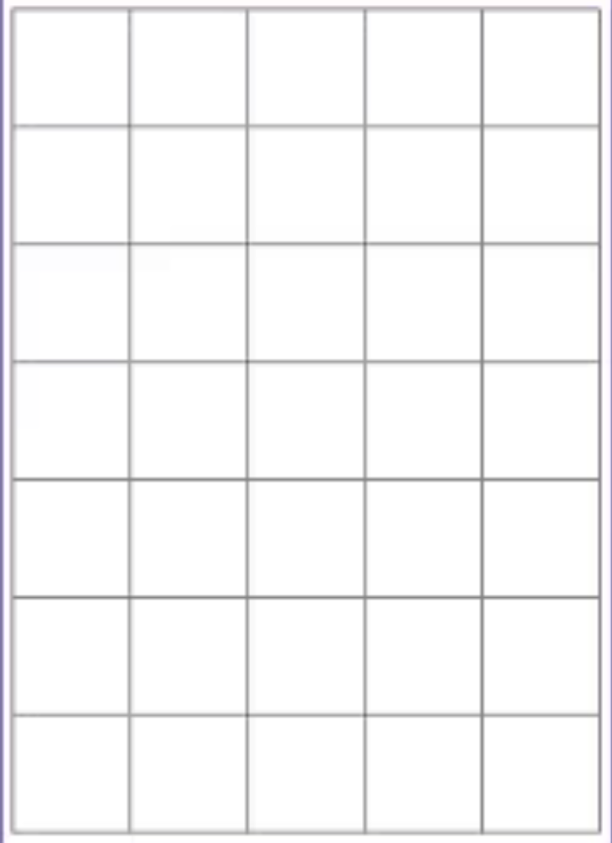

**MATERIALS TO USE**

Paper sheet to cut in rectangles or squares

**3.1 Activity** - Class Exercise: Barter Game

Execution and explanation to the students:

Cut your sheet of paper at the dashed line. Your goal is to trade away your “have” as many

times as you need to finally get your original “want”. You cannot change your original “want”. You will have 5 minutes to accomplish the goal of this exercise.

When your new “have” matches your original “want”, return to your seat. After the time is

up, if you have not found a trading partner, return to your seat anyway.

Raise your hand if you were able to get what you wanted after one trade. Two? Three?

**Answer the following questions briefly but substantially.**

1. Why were some of you able to get someone to trade with and others were not?

________________________________________________________________

________________________________________________________________

2. What are the benefits of barter?

________________________________________________________________

________________________________________________________________

3. Based on your experience with this exercise, what are the drawbacks to using barter?

________________________________________________________________

________________________________________________________________

**Round #2- Commodity Money**

Your teacher has given you one macaroni (for simplicity purposes). Let’s assume that by convention, the price of each good is worth one macaroni.

Your goal again is to obtain what you “want”. But now, our species has smartened up a bit and found a way to solve certain problems.

* Why do we consider macaroni commodity money?
* How do we get the things we want now?
* Was the macaroni round easier?
* Why do you think money has replaced commodities?
* In what ways is using commodity money more efficient than bartering?
* What are the drawbacks to using macaroni as money?
* What do you think happened when Spain started to bring back boatloads of macaroni into your community (gold and silver from the Americas back to Spain)?

# CHAPTER 4: What is Fiat Money and Who Controls It?

**4.1 Activity - Fractional Reserve Banking**

In the following exercise, we’ll explore how fractional reserve banking can lead to currency debasement, inflation, and a decrease in purchasing power. We’ll use a simplified example involving six participants, one of whom will act as a bank, and a reserve ratio that’s still being used a lot today: 10%.

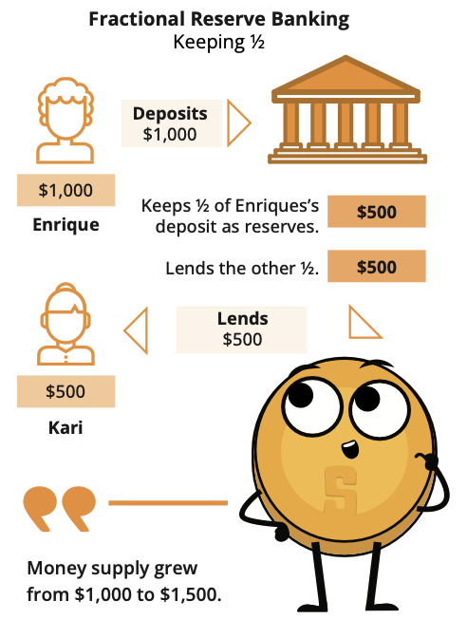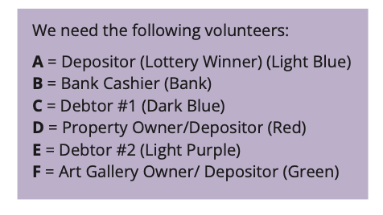

1. A just won $100,000 from the lottery and deposits it in the bank (B). With a 10% reserve ratio, B must keep $10,000 in its vault and can lend out the remaining $90,000.
2. C borrows the maximum amount ($90,000) from B and uses it to buy a house from D.
3. D deposits the $90,000 received from C into the bank (B). The total deposits in the bank are now $190,000.
4. E requests a loan from B, and the bank lends out 90% of the new deposit, which is $81,000.
5. E uses the $81,000 loan to buy an art piece from F, who then deposits the money in the bank (B). The total deposits recorded are now $271,000.

In this scenario, the initial $100,000 deposit has resulted in a total of $271,000 in deposits after circulating through the economy.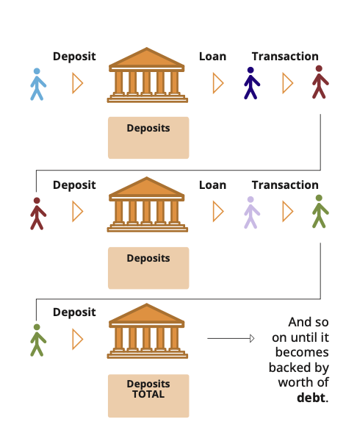

If the reserve ratio were lowered to 1%, the amount of money created would be significantly higher ($100,000 / 0.01 = $10,000,000). In this case, how much money would actually be created with those $100,000 if the money continues to circulate throughout the economy?

It’s important to note that as of 2020, the Federal Reserve (the Central Bank of the USA) reduced reserve requirement ratios to 0% in order to stimulate the economy.

# CHAPTER 5: How Problems Lead to Solutions

## **5.1 Activity - The Effects of Inflation: An Auction Activity**

Objective: To understand the concept of inflation and how it affects the prices of goods and services in an economy.

Definitions:

* The Money Supply: the total amount of money in circulation within an economy at a specific time. This includes:
  + Physical currency, such as coins and bills
  + Checking accounts
  + Savings accounts
  + Money Market accounts
  + Small time deposits (like CDs) under $100,000.00
* Auction: A public sale in which goods or property are sold to the highest bidder.

Class Exercise. Follow the instructions below:

1. You will receive a random amount of monopoly money from the teacher. This represents the money supply in a society.
2. Write down the total money supply in the chart provided.
3. The teacher will auction a candy bar to the students. To win the candy bar, you will need to make the highest bid using your monopoly money. Record the winning bid next to the money supply.
4. The teacher will then add a significant amount of monopoly money to the total money supply. This represents an increase in the money supply in an economy. Later, you will learn how money supply is added or reduced in an economy.
5. The teacher will auction a second candy bar to the students using the same process as before. Record the winning bid next to the money supply on the chart.
6. The teacher will repeat the auction a third time.

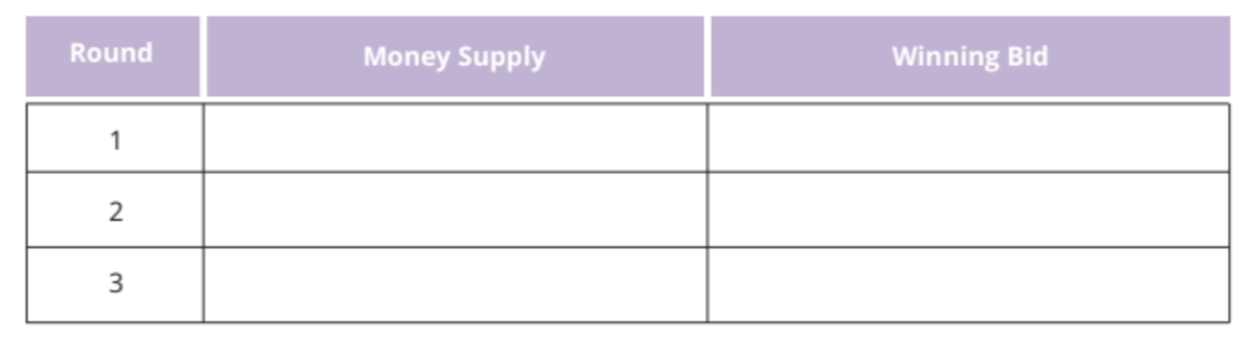

Conclusion:

1. How did the increase in the money supply affect the winning bids for the candy bars?
2. What is the relationship between increasing the money supply and inflation?
3. How is the money supply relevant in the real world?
4. When new money gets injected into the economy, what do you think will happen to the prices of goods and services? Do you think the change in prices are temporary or permanent, and why? How do you think the price changes affect the citizens in a society from a long-term perspective?

**5.2 Activity: Group Socratic discussion: Consequences of the Fiat System**

The class will discuss the following questions:

1. Are there any other consequences that individuals and a society as a whole experience as a result of the fiat system?
2. What are the consequences in your country as a result of the fiat system? What happened throughout history, and how did that affect the people in your country?
   1. Personal examples—interactive session

# CHAPTER 6: An Introduction to Bitcoin

**6.1 Class Activity - Consensus Building in a Peer-to-Peer Network**

**Objective:** To understand how consensus is achieved in a group, learn about cryptography, and the consensus layer of Bitcoin.

**Materials:** Message with encrypted and unencrypted instructions for actions ("attack" or "do not attack").

**Activity Preparation:** The teacher will select a group of 3 or 4 students before class to be malicious nodes in the following activity. The teacher will assign these malicious nodes a cryptographic puzzle as homework in the previous class.

**Exercise Steps:**

**Step 1:** The teacher will select an “originator” who will receive a message on a piece of paper that says "ATTACK," and a series of numbers that says "4-16-14-21-1-21-21-1-3-11-” to one student in the group.

**Step 2:** The students will form a circle in the designated space, ensuring that the selected students who will be malicious nodes are separated to improve the effectiveness of the lesson.

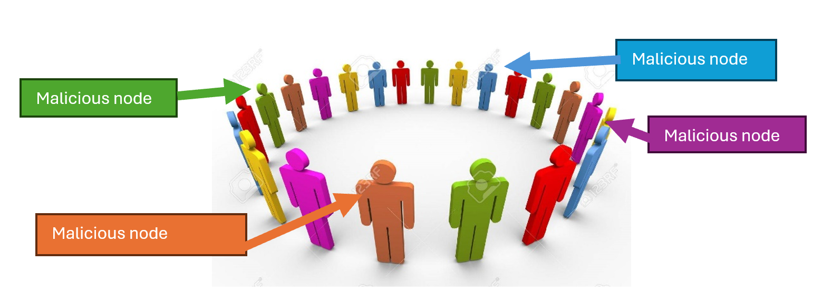

**Step 3:** Once the group has formed a circle, the originator will pass the note to the individual to the right side of the circle.

**Step 4:** After everyone has read the message, the originator will give the signal to the group by saying “Now” and the group will react to the message simultaneously. If the message reads “ATTACK”, then all participants will take a step forward.

**Step 5:** After the initial reaction, some students (those who received the encrypted message and interpreted it correctly) will remain still, while the rest will follow the original instruction, revealing a lack of consensus.

**Conclusion:**

Discuss why consensus was not achieved, introducing the concept of the Byzantine Generals' Problem, and how it relates to the need for a common goal, and later discussing how Bitcoin provides a solution to this problem.

**6.2 Activity: Class discussion** - Is Bitcoin Sound Money?

Now that we have discussed bitcoin in greater detail, let’s look at our money comparison table from Chapter 2 again and see how bitcoin compares with other forms of money:  
  
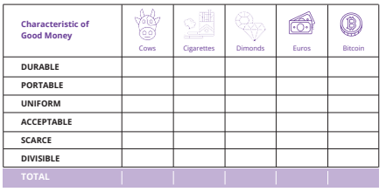

# CHAPTER 7: How to Use Bitcoin

## 

**7.1 Activity: Class discussion and evaluation of Bitcoin wallets on bitcoin.org**

Check out the following resources:

<https://www.lopp.net/bitcoin-information.html>

<https://www.lopp.net/lightning-information.html>

<https://bitcoin.org/en/choose-your-wallet>

And after you’ve done your research use your new knowledge of Bitcoin wallets to select the best one based on the criteria we discussed today.

## **7.2 Activity: Creating your first Bitcoin wallet**

If students do not have cell phones, the teacher will provide one for each student to borrow.   
  
There are two options for this activity:

| **Class Exercise. Option 1. Download a new wallet.** |
| --- |

**How to create and use a Bitcoin wallet.**

1. Search for the app in the App Store (iOS) or Google Play Store (Android).

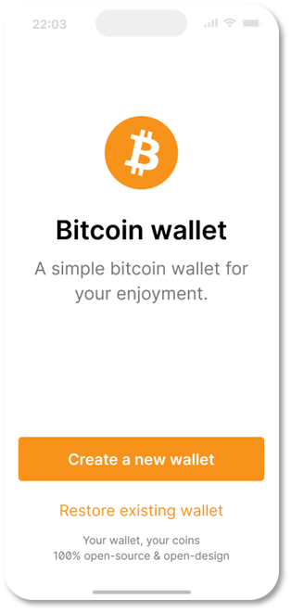

2. Open the app and type in your 12- or 24-word recovery phrase (sometimes called a seed phrase). **Be sure to write it down and keep this in a safe place!** This recovery phrase allows you to recover full access to your funds if needed.   
  
**Remember that if you lose or forget this sequence of words, you will not be able to access your bitcoins if you lose access to your wallet.**

3. **You must then confirm** that you have actually saved your recovery or **seed phrase.** To do this, you must **enter**, in the same order, the **words** of your seed phrase.

4. As an additional measure of security, some wallets allow you to **choose a secure password**. Your **private key** and first **Bitcoin address** are automatically created for you by your wallet.

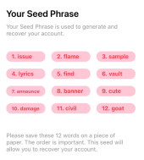

| Think of your public address as your email address – you want to share this with others so they can send you bitcoin, or in the case of an email address, an email.   Think of your private address as the password to your email – you wouldn’t want to share this with anyone as it would give them access to your email. |
| --- |

5. Use your “**receive**” address to receive bitcoin. **Transfer bitcoin to your wallet.** With a self-custodial wallet, you cannot always buy **bitcoin** directly with fiat, so you might need to purchase and transfer it from an exchange first.

| Class Exercise. Option 2. Restore Wallet (Time Limited). |
| --- |

**Download a bitcoin wallet and add some satoshis for each student.**

Give each student a sheet with a seed phrase to retrieve a wallet.

Guide students step by step:

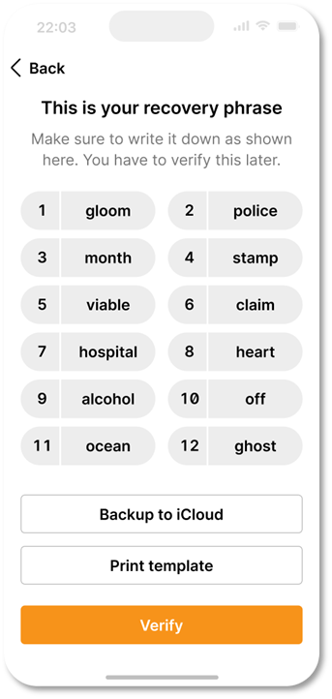

1. When you first start your wallet, you will see three methods of wallet creation, tap **[Import an existing wallet]** You will see an introduction screen, tap **[Restore with recovery phrase]**

2. Enter your 12/18/24-word recovery phrase one by one, in the correct order.

3. Touch **[Restore/Restore]** when finished.

4. You will see an “Import Successful” mode when your wallet has been successfully imported.

**7.3 Activity** - **Bitcoin Transactions in Action**

**Objective**: To understand the underlying concepts and mechanics of a peer-to-peer Bitcoin transaction.

**Before we get started, here’s a quick reminder on the key players in a Bitcoin Transaction:**

1. Senders and Receivers are the parties who wish to transact with each other.
2. Nodes validate transactions and store a complete copy of the blockchain. *Light nodes let people validate transactions while using less storage and fewer computational resources.
3. Miners are responsible for adding new transactions to the blockchain.

Understand your role. You have been assigned one of the following roles: **sender, receiver, node, or miner.**

* Senders will be responsible for creating and broadcasting transactions.
* Receivers will be responsible for receiving and verifying transactions.
* Nodes will be responsible for validating the transactions by checking that the transaction is valid.
* Miners will be responsible for adding the transactions to the blockchain.

1. **As a sender:** Create a transaction.

* To create a transaction, follow these steps: Take a transaction note and write the number of coins you want to send and the name or initials of the receiver. Sign the note with your name or initials, simulating a private key. Pass the transaction note and the corresponding number of coins to the receiver.

**Both nodes and receivers have to verify transactions:**

2. **As a receiver:** You are responsible for verifying the transactions.

Follow these steps:

* Check the transaction note to ensure that the correct number of coins and the receiver’s name or initials are written.
* Count the coins received and compare them to the number of coins written on the note.
* If the coins match, check the approval box. If the coins do not match or you have doubts, reject the transaction

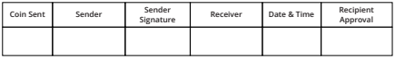

3. **As a node:** Verify and validate transactions. You are responsible for checking that the transaction is valid.

* Verify that the sender’s address is valid and that the receiver’s address is valid.
* Check that the sender has enough funds to complete the transaction and that the transaction does not double-spend any coins

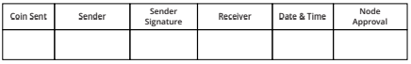

4. **As a miner**: add transactions to the blockchain. You are responsible for adding the transactions to the blockchain.

Follow these steps:

* Check the transactions that have been approved by the receivers and validated by the nodes.
* Roll the dice and compare the numbers with the other miner. The miner with the smaller number will add the transaction to the blockchain.
* For your time, energy, and effort, you will earn a point. At the end of the activity, the miner with the most points wins.

**Once a transaction is added to the blockchain, it cannot be changed or reversed.

5. Keep track of your coin balance: Throughout the activity, keep track of your coin balance by counting the coins in your digital wallet.



6. Discuss the concepts learned with your class.

# CHAPTER 8: Lightning Network: Using bitcoin in your daily life

## **8.1 Activity**: Watch this video on the [Lightning Network](https://www.youtube.com/watch?v=HI38mdTuqHM)

**8.2 Activity**: Class Exercise: **Lightning Wallet Relay Race**

1. First, you will need to download a Lightning wallet onto your phone or computer.

2. Follow the instructions for installing the wallet on your device in section 8.3 of this Chapter.

3. Once the wallet is installed, open it and follow the prompts to set it up. This may involve creating a new wallet or restoring an existing one, and securing it with a password or other form of authentication.

4. Generate a lightning invoice, address, or QR code to receive bitcoin.

5. When your wallet is set up and you are ready to receive satoshis, your teacher will give you and your group a starting amount of satoshis by sending them directly to your wallet.

A. Your group’s goal is to pass the satoshis from one person’s wallet to another, using the Lightning Network, until they reach the last person in the group.

B. To send satoshis to another person, open your wallet and follow the instructions for making a payment. You will need to provide the recipient’s lightning invoice or scan a QR code, and enter the amount of satoshis that you want to send.

C. If your group is the first to successfully send the satoshis to the last person, you win! (And get to keep the sats).

Discuss any difficulties your group had with the activity. Was sending a transaction easy, fast, and inexpensive? Do you think the lightning network is easy to use and understand?

You can take a look at this website for more information and recommendations of lightnight wallets: <https://www.lopp.net/lightning-information.html>

# CHAPTER 9: An introduction to the technical side of Bitcoin

**9.1 Activity** - Watch “How Bitcoin Works under the Hood” [[LINK](https://www.youtube.com/watch?v=Lx9zgZCMqXE)]

**9.2 Activity:** Generate SHA 256 Hash

What is a hash function? Hashing is like a fingerprint for digital data. It is a process of taking a digital message and turning it into a fixed-length code, which serves as a unique identifier.

A hash function is like a secret code machine. It takes in a message and turns it into a code.

Access to this link: <https://tools.keycdn.com/sha256-online-generator>

Instantly generate a SHA256 hash of any string or input value. Hash functions are used as one-way methods.

See how the code always looks the same for the same message. If you change the message even a little, the code will be completely different. This helps computers remember things and check if anything has been changed.

The **output**, or hash, is always the same length, no matter how long the original information was.

**9.3 Activity** - Watch video on Bitcoin Nodes: <https://youtu.be/xc_TxlByxeY>

One of the options to run your own node is to download the Bitcoin Core software, and to give it some time to download the entire blockchain. Once ready, you can leave it on and approximately every 10 minutes, new blocks with transactions arrive. Your node checks their validity, adding them to your local copy of the blockchain.

**9.4 Activity**: What is the Mempool?

Go to this website: <https://mempool.space/>

Review the various elements displayed on the page, including the latest blocks, confirmed transactions, the number of transactions, memory usage, and approximate value of the entire block. Answer the questions:

* What was the last mined block?
* How many transactions were included in that block?
* What is the total value traded in bitcoin?
* What was the size in megabytes of the block?
* How many zeros does the nonce of the block start with?
* How much bitcoin did the miner earn in total?
* What was the total value of fees received by the miner for adding the transactions to the network?
* Choose one of the highest-value transactions in the block. How many Bitcoin addresses was the amount distributed to?

# CHAPTER 10: Why Bitcoin?

**10.1 Activity** - Watch the video [[QR code](https://www.youtube.com/watch?v=3Rnqst5qCgA&ab_channel=SwanBitcoin)]

**10.2 Activity** - Final Class Discussion: How did your perspective change?   
  
Please answer the 5 questions below:

Why do we need money?

_______________________________________________________________________

What is money?

_______________________________________________________________________

Who controls money?

_______________________________________________________________________

*What gives money its “value”?*

_______________________________________________________________________

What question do you have about money? Write down your question here to share with the class.

_______________________________________________________________________

1. Go back to the first activity in Chapter 1, and compare your new answers to your old answers.
2. Compare and discuss the original answers and questions. Did something change?
3. Ask yourself this final question: What is my next step? And how can I use this new knowledge to empower myself?